A Seismic Multi-Attribute Sandbody
Identification Method Based on the LightGBM-
RFECV Coupling Algorithm
Teng-fei Ren, Zhi-bing Feng^{1,2,}*, Ying Zhang, Xiang Zhang, Li Jiang¹, Yuan-li Ning⁴,
Jing-yi Wang¹, Jian Ding¹, and Zeng-shuo Qi¹
Abstract: Seismic attributes encapsulate substantial reservoir characterization information and can effectively support reservoir prediction. Given the high-dimensional nonlinear between sandbodies and seismic attributes, this study employs the RFECV method for seismic attribute selection, inputting the optimized attributes into a LightGBM model to enhance spatial delineation of sandbody identification. By constructing training datasets based on optimized seismic attributes and well logs, followed by class imbalance correction as input variables for machine learning models, with sandbody probability as the output variable, and employing grid search to optimize model parameters, a high-precision sandbody prediction model was established. Taking the 3D seismic data of Block F3 in the North Sea of Holland as an example, this method successfully depicted the three-dimensional spatial distribution of target formation sandstones. The results indicate that even under strong noise conditions, the multi-attribute sandbody identification method based on LightGBM effectively characterizes the distribution features of sandbodies. Compared to unselected attributes, the prediction results using selected attributes have higher vertical resolution and inter-well conformity, with the prediction accuracy for single wells reaching 80.77%, significantly improving the accuracy of sandbody boundary delineation.
Keywords: Sandbody identification; Seismic attributes; LightGBM model; RFECV method

Introduction
Sandbodies are an important component of oil, gas, and uranium reservoirs in sedimentary basins (Feng et al., 2017, 2024; Cheng et al., 2025; Peng et al., 2025). Understanding their location and shape helps in better exploration and development. Lithology, a core parameter controlling reservoir properties, directly
influences petrophysical characteristics and fluid distribution, holding significant importance for accurate reservoir description (Cheng et al., 2022; Chaki et al., 2015). Current sandbody identification methods primarily rely on seismic attribute analysis and seismic inversion techniques, which acquire lithological information by establishing statistical relationships between lithology and petrophysical parameters or inversion parameters (Garia et al., 2021). Han (2021) revealed the

Manuscript received by the Editor March 19, 2025; revised manuscript received August 31, 2025
lithofacies development pattern and predicted sandbody development zones in the Yingcheng Formation of the Xuxi area based on multi-attribute analysis. Zhang et al. (2024) analyzed the connectivity of shallow sandbodies in the Bohai Depression using seismic fusion attributes. While these methods have yielded robust outcomes in specific geological contexts, their application faces significant limitations. Conventional methods are highly dependent on data quality and inversion accuracy. Furthermore, noise interference and inversion uncertainties during actual seismic data processing often reduce prediction reliability, making it difficult to meet the demands of detailed reservoir characterization (Fan et al., 2023).
Machine learning methods, owing to their powerful data mining capabilities, demonstrate significant advantages in pattern recognition and classification prediction. By training models on known data, this approach enables reliable prediction in unknown regions (Jiang et al., 2024; Chenin et al., 2020). In hydrocarbon exploration, Othman et al. (2021) predicted reservoir properties using seismic amplitude data via a probabilistic neural network (PNN) algorithm. Xiong et al. (2021) utilized bidirectional long short-term memory neural networks for lithofacies prediction in areas with sparse well control. Extensive research shows that LightGBM, as an efficient gradient boosting decision tree framework, outperforms traditional machine learning algorithms in training speed, accuracy, and memory efficiency. The framework employs a histogram algorithm for feature parallel optimization, significantly enhancing computational efficiency. Addressing the characteristics of large seismic data volumes and high feature dimensionality, LightGBM proposes two innovative algorithms: Gradient-based One-Side Sampling (GOSS) and Exclusive Feature Bundling (EFB). These optimize the computational process from the dimensions of sample sampling and feature handling, respectively, substantially improving computational efficiency while maintaining prediction accuracy.
Compared to raw seismic data, seismic attributes exhibit higher sensitivity to variations in reservoir properties and lithology, effectively revealing implicit geological features within the reservoir, and hold significant application value in reservoir prediction and lithology identification. The nonlinear relationship between seismic attributes and sandbodies is the core issue in sandbody identification research (Sun et al. 2025; Jiang et al. 2024). Notwithstanding, a single
seismic attribute is insufficient for accurate sandbody prediction, while combining too many attributes may introduce information redundancy, reducing model generalization. Conventional methods typically rely on cross-plot analysis of seismic attributes or elastic parameters for lithology identification, but this approach has clear limitations: firstly, elastic parameters for different lithologies often exhibit overlapping regions; secondly, cross-plot interpretation heavily relies on manual identification, which is subjective and has poor reproducibility (Yan 2022). Consequently, constructing an optimal seismic attribute subset is crucial for improving the sandbody identification accuracy of machine learning models. The RFECV algorithm effectively selects the most representative subset of features by recursively eliminating redundant ones and incorporating cross-validation to evaluate model performance. Its model-agnostic nature, not relying on any specific machine learning algorithm, enhances the stability and generalization capability of feature selection. In the context of sandbody identification, this method can effectively address the challenges posed by high-dimensional data, providing robust and interpretable feature selection results with significant practical value (Wang et al., 2019).
Consequently, we propose a solution based on the LightGBM machine learning algorithm. This method employs RFECV technology for optimized seismic attribute selection and utilizes a grid search strategy for model parameter tuning, ultimately constructing a high-precision sandbody identification model. Practical application demonstrates that this method can effectively identify sandbody distribution features in seismic sections, with prediction results showing good agreement with measured data, validating the method's practicality and reliability.

Method Principle

Well-to-Seismic Matching
Supervised machine learning algorithms require a sample set with calibrated labels for training (Silveira et al., 2024). Consequently, well log lithology data with known sandbody information is essential for machine learning-based sandbody identification. To integrate sandbody information with seismic attribute data, well- to-seismic matching is necessary. Based on the time-
depth conversion relationship obtained from well-to- seismic calibration, well log lithology data in the depth domain is converted to the time domain. Due to differing sampling rates between well log and seismic data, the well log data must be resampled according to the seismic data's sampling rate to achieve consistency in the time domain (Kumar et al., 2018; He et al., 2020). Using the inline and crossline values of the wells, multiple seismic attributes and elastic parameters are extracted point-by-
point from the adjacent seismic traces as features for lithology samples. These are combined with the time- converted and resampled well log lithology data to form the initial seismic attribute sample set. As shown in Fig. 1, the sample set is based on individual sampling points, with corresponding data including time-domain data, lithology data, seismic attributes, and elastic parameters for that point.

Fig. 1 Schematic diagram of typical well-log and seismic data matching results. On the far left is lithology, where blue represents mudstone and yellow represents sandstone. From left to right are: natural gamma, instantaneous amplitude, P-wave impedance, and 24 Hz frequency-divided energy.
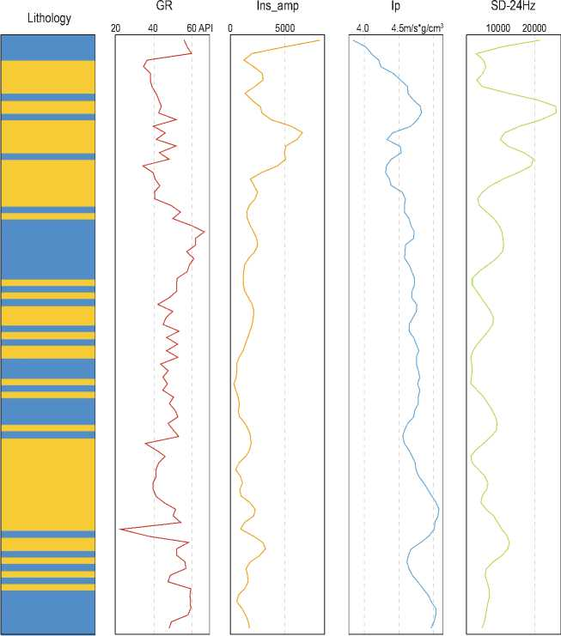

Seismic Attribute Optimization
Seismic attributes refer to special measures derived through mathematical transformations, describing seismic waves in geometric, dynamic, and statistical aspects, capable of characterizing reservoir structure, properties, and lithology. They can be classified into phase attributes, amplitude attributes, absorption attenuation attributes, and frequency attributes.
Attributes like amplitude, frequency, phase, P-wave and S-wave velocity, acoustic impedance, and absorption coefficient are primarily used for lithology and reservoir characterization interpretation. A single seismic attribute is easily influenced by sand-mudstone configurations, limiting sandbody identification accuracy and often leading to ambiguity. Inputting an excessive number of seismic attributes can also degrade machine learning
performance, as not all attributes positively contribute to sandbody identification (Li et al., 2021; Shi et al., 2023). Consequently, when handling multiple seismic attribute features, it is necessary to optimize and select attributes highly correlated with sandbodies. This reduces the training data size, accelerates model training, avoids insufficient features from a single attribute, and prevents overfitting (Huang et al., 2025). Recursive Feature Elimination with Cross-Validation (RFECV) is a feature selection technique combining Recursive Feature Elimination (RFE) and Cross-Validation (CV), designed to automatically determine the optimal number of features. This algorithm does not require pre-setting the number of features to retain; instead, it dynamically determines the optimal feature count through crossvalidation. It supports any supervised learning model that provides feature importance scores and exhibits good model generalization. Hence, the RFECV algorithm is used to optimize seismic attributes, selecting those highly correlated with sandbodies. The RFECV process can be summarized in the following steps:
- Initialization: Given the training dataset X ∈ R^n*m (n: number of samples, m: number of original features) and labels y, select a supervised learning model capable of outputting feature importance, set the number of cross-validation folds k, and define the number of features to remove per iteration.
- Feature Importance Calculation & Ranking: Train the base model M on the full feature set X, employing cross-validation to avoid initial overfitting. Extract feature importance scores S = {s1, s2, ..., sm} based on the model's characteristics. Rank features in descending order of importance score S, generating the ranked list F_rank = [f(1), f(2), ..., f(m)], where f(1) is the most important feature.
- Recursive Feature Elimination & CrossValidation Iteration: Starting with the full feature set, the algorithm enters an iterative loop. In each iteration, it performs k-fold cross-validation on the current feature subset: the data is divided into k parts, the model is trained on k-1 folds, and its performance is validated on the remaining fold. The average cross-validation score is computed to assess the generalization ability of the current feature subset. Based on the pre-ranked feature importance list, the least important features (a predefined number) are then removed, resulting in a smaller feature subset. This process continues until the number of remaining features reaches a preset minimum or the cross-validation score drops significantly. Throughout
the iterations, both the number of features and their corresponding scores are recorded to generate a featurenumber vs. performance curve.
- Optimal Feature Subset Selection: Analyze the feature-number vs. performance curve and select the feature number m_opt yielding the highest crossvalidation score. If multiple feature counts yield similar scores, the principle of parsimony is followed to choose the smallest number. Ultimately, the top m_opt features from the original ranked list F_rank are retained to form the optimal subset F_final. This subset reduces dimensionality while preserving maximum predictive power, with generalization ensured through crossvalidation (Xing et al., 2023).

LightGBM Principle
LightGBM is an efficient machine learning framework based on Gradient Boosting Decision Trees (GBDT), proposed by Microsoft in 2017. It is adaptable to diverse machine learning scenarios, including ranking, classification, and regression tasks, and has been widely applied in fields such as finance, medicine, and geoscience, becoming a primary method for solving classification and regression problems using data-driven models (Ke et al., 2017). The essence of LightGBM is an ensemble algorithm that transforms weak learners into strong learners. It combines numerous low-accuracy tree models, iterating continuously using gradient descent. In each iteration, the loss function is minimized by moving in the negative gradient direction of the loss function, ultimately resulting in a high-performing tree used as the prediction model. LightGBM supports three parallelization methods: feature parallel, data parallel, and voting parallel, effectively enhancing processing speed. Compared to other ensemble learning methods, LightGBM offers faster processing time and higher accuracy when handling data with high feature dimensionality and large sample sizes (Dramsch, 2020). This is primarily due to two innovative algorithms: Exclusive Feature Bundling (EFB) and Gradient-based One-Side Sampling (GOSS).
In high-dimensional data processing, exploding feature dimensions can significantly reduce model training efficiency. Traditional gradient boosting tree algorithms search for the optimal split point by traversing all features. Seismic sandbody identification data typically contains numerous seismic attributes (e.g., amplitude, frequency, coherence volume), often exhibiting high sparsity and partial mutual exclusivity among features
(Hampson et al., 2001; Dixit et al., 2020). LightGBM's EFB algorithm addresses computational efficiency through feature dimensionality reduction. The core idea of EFB is to merge mutually exclusive features— defined as features with near-zero correlation—into a single synthetic feature, thereby reducing the feature search space. EFB allows LightGBM to traverse only the bundled features during training instead of the original features, reducing computational complexity from O(#data × #feature) to O (#data × #bundle). In seismic sandbody identification, this method effectively compresses seismic attribute dimensions, accelerates model training, and retains key information about formation reflection characteristics.
Addressing computational bottlenecks in massive sample scenarios, LightGBM proposes the GOSS algorithm. Traditional random sampling discards high-gradient samples (i.e., samples with large model prediction errors), whereas GOSS significantly improves sampling efficiency by retaining these high-information samples. Let a denote the top samples selected based on the absolute values of the gradients, and b represent the remaining samples. By combining these two subsets of samples using the GOSS algorithm, the computational cost can be significantly reduced while maintaining the effectiveness and accuracy of model training. The theoretical time complexity is reduced to O((a + b)% × #data × #feature). In seismic sandbody identification, this method prioritizes learning sensitive features in seismic waveform anomalous zones (e.g., sandbody boundaries), avoiding overfitting to stable background regions, thereby enhancing model generalization capability.
The EFB and GOSS algorithms optimize computational efficiency from the feature space and sample space, respectively, forming a "dual dimensionality reduction" mechanism. EFB reduces feature search times, while GOSS lowers sample computation. Their combination enables LightGBM to achieve 3-5 times speedup compared to algorithms like XGBoost when training large-scale seismic data. Furthermore, the gradient focusing characteristic causes the model to pay more attention to the discrimination boundary between sand and non-sand, improving the identification accuracy of thin interbedded sandbodies. This computational efficiency characteristic is particularly significant for capturing weak reflection signals in seismic data.

Method Workflow
The seismic multi-attribute sandbody identification method based on the LightGBM-RFECV coupling algorithm mainly includes the following steps: 1. Data Processing:Identify the location and seismic reflection characteristics of the target interval. Extract seismic data and elastic parameters (including various attribute volumes like amplitude, frequency, phase) for the target interval. 2.Well-to-Seismic Matching: Combine well log data with seismic data. Extract seismic attributes and lithology data along the time domain at well locations to establish the initial sample set. 3.Seismic Attribute Optimization: Based on the RFECV method, use the initial sample set as input data to optimize the extracted seismic attributes, obtaining the subset most highly correlated with sandbodies. Apply the optimized attributes to the seismic data at well locations and combine them with well log lithology data to form the optimized sample set. 4. Class balance correction: Perform class balance on the optimized sample set to equalize the number of sandstone and mudstone samples. Use this balanced set as the input data for the LightGBM model. 5.Grid Parameter Tuning: Construct the LightGBM model. Split the input data into training and test sets in an 8:2 ratio. Utilize GridSearchCV grid search to optimize and tune the LightGBM model parameters, identifying the optimal parameter combination to maximize model performance and enhance generalization. 6.Predict SandBody Distribution in Sections: Extract seismic attributes for the target interval along seismic sections containing wells. Optimize these attributes using the selected subset. Input the optimized attributes into the trained LightGBM model to predict the sandbody distribution within the target interval of that section. The method flowchart is shown in Fig. 2.

Field Application
The data used in this study is from the publicly available OpendTect dataset for the F3 Block in the Dutch North Sea (https://terranubis.com/datainfo/F3- Demo-2023). This area exhibits a prominent large-scale S-shaped reflection on seismic data, characteristic of a river-dominated delta primarily composed of sandstone
and mudstone. Available data includes 3D post-stack seismic data, seismically inverted P-impedance data, geostatistically inverted natural gamma ray data (totaling 11 seismic attributes), and lithology data from four wells within the block.
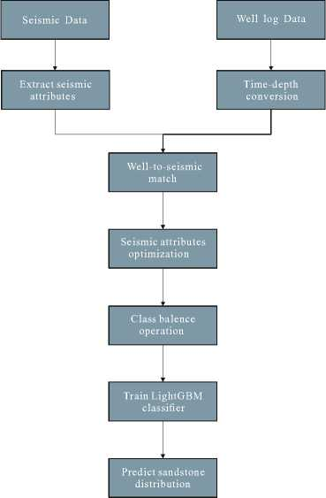
Fig. 2 Method workflow diagram.
Software versions used: Python 3.8.19, pandas 1.3.5, scikit-learn 1.0.2, LightGBM 3.3.0.

Well-to-Seismic Matching
We performed well-to-seismic matching for the four known wells. Due to inherent differences in data acquisition physics between well logs (point measurements) and seismic survrys (volume illumination),, well log data must be converted from the depth domain to the time domain using the timedepth conversion file before prediction to establish correspondence between seismic and well log data. The known seismic data sampling rate is 4ms. Consequently, the depth-converted well log data was resampled at 4ms to ensure consistency with seismic data in the time domain. Grid data sampling was used to extract seismic data from traces adjacent to the wells. Well log data and seismic data at the same time were combined (Wang et al., 2018). As the block is primarily composed of sandstone and mudstone, only these two lithologies were retained. To ensure the input data format is recognizable by the machine learning model, mudstone was coded as 0 and sandstone as 1, constructing the initial sample set as shown in Table 1. Due to the limited number of wells with known lithology (four) and the 4ms seismic sampling rate, the number of lithology samples is relatively small.

Table 1: Initial Sample Set Table (0 represents mudstone, 1 represents sandstone)
Lithology | Gamma | P-Impedance | Instantaneous Amplitude … | 24Hz Spectral Energy
1 | 53.9605 | 4390450 | 3097.27 … | 11748.41
0 | 71.4770 | 4429119 | 1260.23 … | 6687.47
0 | 33.3063 | 4398373 | 1953.05 … | 2799.13
1 | 49.5887 | 5179910 | 2822.58 | 6400.67
0 | 46.8625 | 5351423 | 3586.86 | 5144.18

Seismic Attribute Optimization
A single seismic attribute can lead to ambiguity, while too many attributes can adversely affect sandbody identification. Consequently, a machine learning approach was used for seismic attribute optimization. Given the limited labeled data available, the quality of features becomes far more important than their quantity, necessitating rigorous feature engineering. For this block, 11 seismic attributes were selected for analysis and optimization: natural gamma ray, P-impedance, amplitude, instantaneous amplitude, instantaneous
frequency, RMS energy, amplitude kurtosis, quality factor Q, and spectral energy at 24Hz, 44Hz, and 64Hz. After well-to-seismic matching, we combined these attributes with well log lithology data to form the initial sample set and then standardized the data to eliminate unit differences. To screen for attributes highly correlated with sandbodies, we performed attribute optimization using the RFECV method. The LightGBM classifier was selected as the base model. The RFECV recursion step size was set to 1, and cross-validation folds were set to 5. Balanced accuracy was chosen as the evaluation metric
to balance computational efficiency and result stability. We performed recursive feature elimination on the initial sample set. Feature importance was calculated in each iteration, and the lowest-ranked attribute was eliminated until all features were removed. Using 5-fold crossvalidation, the model's CV score on the validation set was computed for each fold. The feature subsets' scores were compared, and the subset with the highest score was selected as the optimal combination.
Fig. 3 shows the CV scores for subsets of different
sizes. The highest score (0.664) was achieved with 8 features. Consequently, this was chosen as the optimal subset. Within this subset, attributes ranked by importance (highest to lowest) are: Natural Gamma Ray, P-Impedance, 24Hz Spectral Energy, Instantaneous Frequency, 64Hz Spectral Energy, 44Hz Spectral Energy, Instantaneous Amplitude, and RMS Energy, as shown in Fig. 4. Using this subset as the standard, the sample set was refined to retain only the optimized seismic attributes.

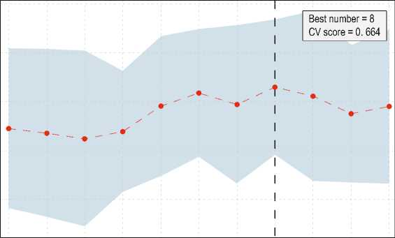
0.75
0.70
<л
о
8
О 0.65
го
"го
сл (Л
о 0.60
0.55
1 2 3 4 5 6 7 8 9 10
Feature subset size
Fig. 3 Optimal feature subset score plot. The CV score is highest when the number of features in the subset is 8.

Fig. 4 Feature importance ranking plot.
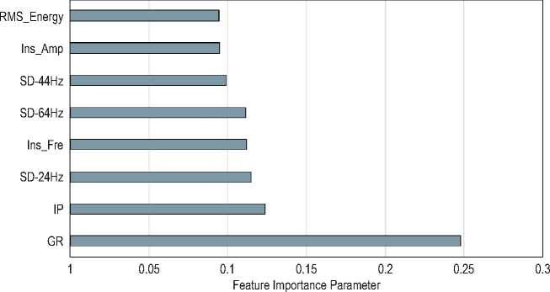

The natural gamma log records the radioactivity intensity of the formation, primarily produced by radioactive elements. Since pure quartz sand contains almost no radioactive elements and mudstone contains a relatively high amount of clay minerals, areas with lower natural gamma values may indicate the presence of sandbodies. P-wave impedance is the product of
density and P-wave velocity, reflecting the resistance encountered by seismic waves as they pass through a medium. Generally, the P-wave impedance of sandstone is lower than that of the surrounding rock formations. Frequency-divided energy refers to the energy level of seismic signals at specific frequencies. Different types of rocks respond differently to seismic waves of different
frequencies. Instantaneous amplitude describes how the amplitude of seismic data changes over time. The acoustic impedance difference between sandbodies and surrounding rocks causes variations in the amplitude of reflected waves, aiding in the identification of sandbody locations. This information collectively helps in distinguishing and identifying sandbodies within geological formations effectively.

Class imbalance correction
To mitigate the impact of class imbalance on the machine learning model, Synthetic Minority Oversampling Technique (SMOTE) was applied to the existing sample set. This technique synthesizes minority class samples to increase their representation within the sample set, thereby improving model generalization ability (Chawla et al., 2002; Zhou et al., 2020). The result of the class imbalance correction is shown in Fig. 5.
Class distribution after balancing
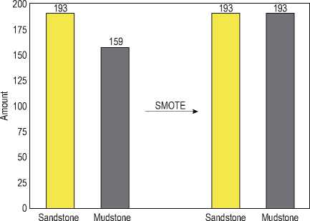
Fig. 5 Class imbalance correctionresult plot.

LightGBM Application
A LightGBM model was constructed to establish the mapping relationship between seismic attributes and sandbodies. To address potential issues like missing values or outliers in the seismic attribute data, the optimized sample set underwent data preprocessing, including removing invalid and outlier values. Notwithstanding, as LightGBM is a tree-based model where numerical scaling does not affect split point positions, standardization was not applied to the optimized sample set. The preprocessed, optimized sample set served as input data. Due to the limited sample size, reserving an entire well log for testing was not feasible. Instead, the entire sample set was split into training and test sets in an 8:2 ratio.
The key to model performance lies in parameter selection. This study used the sklearn API version of LightGBM combined with grid search for parameter tuning and optimization. The learning rate was set to 0.1 after sensitivity analysis, and early stopping was set to 30 rounds to expedite the tuning of other parameters. Parameters like number of boosted trees, maximum number of leaves, subsample ratio for training data, subsample ratio of features for each tree, L1 regularization term on leaf weights and L2 regularization term on leaf weights were optimized sequentially. The learning rate determines the speed at which the model converges. A smaller learning rate, combined with a larger number of number of boosted trees, can achieve better generalization performance. The maximum number of leaves directly influences the expressive power of a single tree; notwithstanding, a larger value significantly increases the risk of overfitting. Subsample ratio for training data and subsample ratio of features for each tree can reduce overfitting and improve training speed. These parameters control the fraction of data and features used for training each tree, respectively, thereby adding randomness to the training process which helps in reducing overfitting. L1 regularization term on leaf weights and L2 regularization term on leaf weights serve as regularization parameters. Lambda_l1 applies L1 regularization which can lead to sparse solutions where some feature weights are reduced to zero, effectively performing feature selection. Lambda_l2 applies L2 regularization which penalizes the square of the weights, leading to smaller and more diffuse weight values across all features, helping to prevent overfitting by discouraging the model from becoming overly complex. By tuning these parameters appropriately, one can enhance the model's ability to generalize well to new, unseen data while mitigating the risk of overfitting. Finally, we performed a grid search for the optimal learning rate based on this optimized parameter set, determining its final value based on the score, resulting in the optimal parameter set, The optimal parameter set obtained is: learning_rate: 0.03, number of boosted trees = 300, maximum number of leaves = 14, subsample ratio for training data = 0.2, subsample ratio of features for each tree = 0.9, L1 regularization term on leaf weights = 0.3, L2 regularization term on leaf weights = 0.01. The ROC curve after tuning is shown in Fig. 6. The AUC value reached 0.823, significantly better than random guessing, demonstrating good sand-mudstone discrimination capability.
The optimal parameter set was used as the parameters for the LightGBM model. The optimized seismic attribute set served as input data, and lithology data served as labels for training the LightGBM model. LightGBM training utilizes an ensemble learning approach with multiple decision trees for classification.
Validation ROC
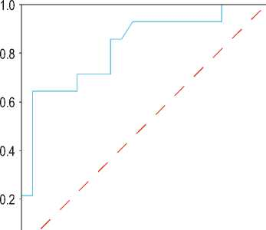
. / ь Val AUC = 0.823
0
0.2 0.4 0.6 0.8 1.0
False Positive Rate
Fig. 6 ROC curve after parameter tuning.

It first selects the feature and split point providing the highest information gain for sandbodies. Continuous features are discretized into histograms, reducing computation and supporting parallelization. Logarithmic loss (log loss) is used to measure the difference between predicted probabilities and true labels. Each tree fits the negative gradient of the previous tree, progressively optimizing the loss function. After training, sections containing known wells were selected for prediction. Based on the inline and crossline values of a well, the optimized seismic data for the target interval along that section was sliced. These optimized seismic attributes were input into the trained LightGBM model for prediction. To predict sandbodies, seismic attribute data is input sequentially into each decision tree. Based on node splitting rules, the data is directed to leaf nodes. Finally, the prediction score sums from the leaf nodes of all trees are aggregated. A Sigmoid function converts this sum into a probability, indicating the likelihood of a sample point being sandstone. After obtaining the prediction results, the probability threshold was finetuned based on the visual outcome to determine the best prediction effect. The prediction accuracy for single wells is highest when the probability threshold is set to 0.65. Additionally, the resulting sandbody distribution aligns well with actual geological understanding.
Consequently, a probability of 0.65 is determined as the optimal threshold for classification. Sample points with a sandstone probability ≥ 65% are classified as sandstone; those < 65% are classified as mudstone.
For the single-well section selected within the 3D volume, the predicted sand-mudstone distribution achieved a maximum accuracy of 80.77% when validated against the actual well log interpretation results from the blind well F03-4. The prediction results for all sample points along the section were integrated to generate the final predicted section.

Prediction Result Analysis
Due to the complexity of seismic data and potential errors in well log data collection and processing, overemphasizing exact agreement between prediction results and well log lithology labels may not yield the best predictive outcome. As shown in the prediction figures for well F03-2 (Fig. 7), well F03-4 (Fig. 8), and the 3D view of F03-4 (Fig. 9), the images display inline slices at the locations of wells F03-2 and F03-4, along with the seismic profile and predicted sandbody distribution in 3D around well F03-4. The original seismic data in the F3 Block contains significant noise, which impacts the prediction results. The sandbody results predicted by the LightGBM method show high consistency with the two well logs. The distribution of sandbodies between wells corresponds well with the extension of seismic reflectors. Overall, sandstone layers in this block are primarily located at the top of the target interval, mudstone layers at the bottom, with sandmudstone interbeds in the middle. As shown in Figures 7 and 8, the prediction results for slices containing both wells exhibit this characteristic, demonstrating good stability. Unlike conventional understanding where sandmudstone distribution is heavily influenced by seismic amplitude, the feature importance ranking (Fig. 4) indicates that distribution in this area is most influenced by natural gamma ray values: high values typically correspond to mudstone, low values to sandstone. Strong correlations also exist with other highly important attributes like 24Hz spectral energy and P-impedance, reflecting unique characteristics of this region. Compared to results using all 11 attributes, predictions using the optimized 8 attributes show finer and more precise delineation between sandstone and mudstone, and more accurate identification of subtle sandbodies, better depicting their spatial extent and location. As shown in Fig. 9, it presents the three-dimensional
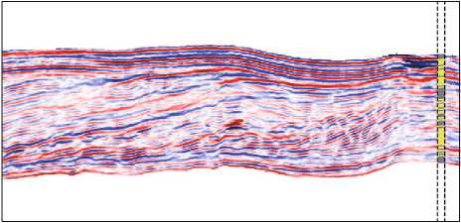
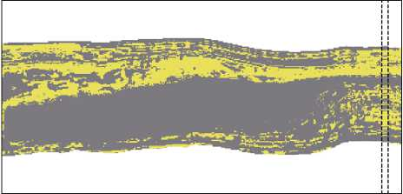
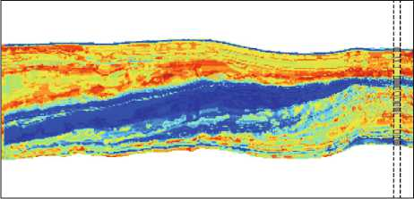
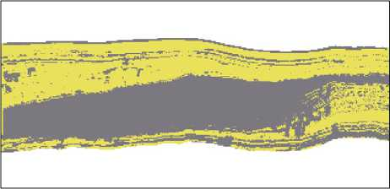
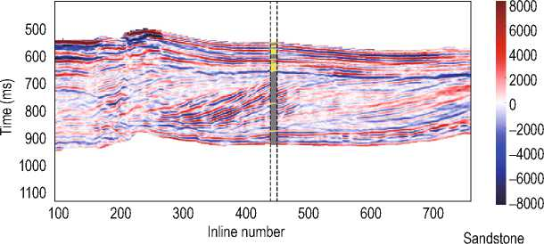
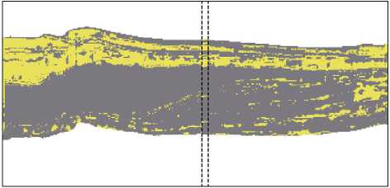
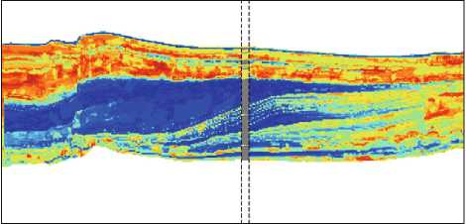
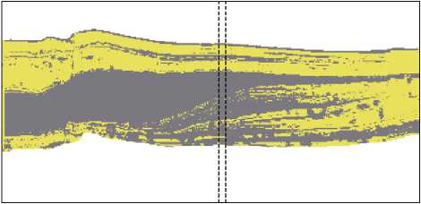
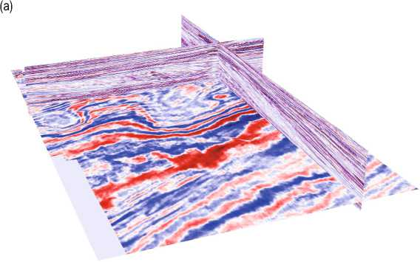
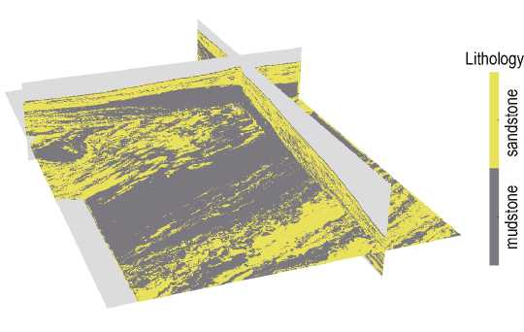
(a)
Amplitude
(b)
Lithology
(c)
500
600
Е 700
Е 800
900
1000
1100
100 200 300 400 500 600 700
8000 6000
4000 2000
0 –2000 –4000 –6000 –8000
Inline number
500
600
Е 700
Е 800
900
1000
1100
100 200 300 400 500 600 700
Inline number
Sandstone
(d)
Lithology
500
'от' 700
probability 0.9
0.8
0.7
0.6
0.5
0.4
0.3
0.2
0.1
900
1000
1100
100 200 300 400 500 600 700
Inline number
500
600
'от' 700
Е,
Е 800
900
1000
1100
100 200 300 400 500 600 700
Inline number
Fig. 7 Prediction results for Well F03-2. (a) Seismic section of the target interval; (b) Prediction result using the optimized 8 attributes; (c) Sandstone probability map for the target interval; (d) Prediction result using all 11 attributes.
(c)
probability
500
600
700
800
900
1000
1100
0.9
0.8
0.7
(b) Lithology
Е
100
700
500
600
700
800
900
1000
1100
200 300 400 500 600
Inline number
(d)
100 200 300 400 500 600 700
0.6
0.5
0.4
0.3
0.2
0.1
Inline number
500
600
700
800
900
1000
1100
100 200 300 400 500 600 700
Inline number
Lithology
Fig. 8 Prediction results for Well F03-4. (a) Seismic section of the target interval; (b) Prediction result using the optimized 8 attributes; (c) Sandstone probability map for the target interval; (d) Prediction result using all 11 attributes.
Amplitude 8000
6000
4000
2000 0
–2000 –4000 –6000 –8000
(b)
Fig. 9 3D view of Well F03-4. (a) 3D seismic section containing F03-4; (b) Prediction result using the optimized 8 attributes.
distribution of sandbodies in the area of well F03-4. The gray areas represent non-target layers, with sandstone
layers predominantly located above and mudstone layers below. This is consistent with the prediction

results from a single section. It can be observed that the deltaic deposits spread in a northeast-southwest direction. This visualization helps in understanding the spatial relationship and geological structure of the subsurface, providing insights into the depositional environment and aiding in the accurate identification of potential hydrocarbon reservoirs or aquifers. Overall, the prediction results demonstrate good accuracy and continuity, showing a strong correspondence with well log lithology and aligning well with the actual distribution of sandbodies.

Conclusions
This paper proposes a seismic multi-attribute sandbody identification method based on the LightGBM- RFECV coupling algorithm. After performing well- to-seismic matching on seismic and well log data, the RFECV method is used to optimize and select the seismic attribute subset most highly correlated with sandbodies. This subset is input into the LightGBM model for training. Grid parameter tuning is employed to find the LightGBM model with optimal performance. The trained model was used to predict sandbodies in seismic sections from a field block. Results demonstrate that this method can more accurately delineate sandbody regions.
LightGBM effectively compresses seismic dimensionality, increasing model training speed while preserving key formation reflection characteristics. The RFECV method optimizes the seismic attribute set using a machine learning model; the selected attributes show high correlation with sandbodies. Using this subset as input data achieves finer prediction results. Using the seismic attribute subset as input data and sandbody information as sample labels effectively captures the nonlinear relationship between sandbodies and seismic attributes, deeply mining the underlying feature information within the data. Predicting sandbodies along sections containing two wells in the Dutch North Sea F3 Block yielded results that accurately reflect the sandbody distribution in these sections, achieving geologically reasonable predictions. This verifies the method's practicality and provides a new approach for seismic sandbody identification.
Funding: This study was co-funded by the China National Nuclear Corporation-State Key Laboratory of Nuclear Resources and Environment (East China
University of Technology) Joint Innovation Fund Project (No. 2023NRE-LH-08), the Natural Science Foundation of Jiangxi Province, China (No. 20252BAC240270), the Funding of National Key Laboratory of Uranium Resources Exploration-Mining and Nuclear Remote Sensing (2025QZ-YZZ-08), and the National Major Science and Technology Project on Deep Earth of China (No.2024ZD1003300).

Declaration of Interest Statement
The authors declare that they have no known competing financial interests or personal relationships that could have appeared to influence the work reported in this paper.

References
Chaki, S., Routray, A., and Mohanty, WK., 2015, A novel preprocessing scheme to improve the prediction of sand fraction from seismic attributes using neural networks: IEEE J Sel Top Appl Earth Obs Remote Sens 8(4):1808–1820.
Chawla, N., Bowyer, K., and Hall, L., et al, 2002, SMOTE: synthetic minority over-sampling technique: Journal of Artificial Intelligence Research 16, 321-357.
Cheng, J., Wang, D., and Li, Z., 2022, Application Prospect of Seismic Exploration Technology in the Exploration and Development of In-situ Leachable Sandstone Uranium Deposit: Uranium Geology 38 (02), 317-326.
Cheng, YH., Petrov, V., and Jin, RS., et al, 2025, Neotectonic controls on large-scale uranium mineralization in the Meso-Cenozioc basins, Northern China: Ore Geology Reviews 176, 106393.
Chenin, J., and Bedle, H., 2020, Multi-attribute machine learning analysis for weak BSR detection in the Pegasus Basin, Offshore New Zealand: Marine Geophysical Research 41(4), 21.
Dixit, A., and Mandal, A., 2020, Detection of gas chimney and its linkage with deep-seated reservoir in Poseidon, NW shelf, Australia from 3D seismic data using multi-attribute analysis and artificial neural network approach: Journal of Natural Gas Science and Engineering 83.
Dramsch, JS., 2020, 70 years of machine learning in geoscience in review: Advances in Geophysics 61, 1–55.
Fan, M., Xiao, K., and Sun, L., et al, 2023, Metallogenic prediction based on geological-model driven and data- driven multisource information fusion: A case study of gold deposits in Xiong’ershan area, Henan Province, China: Ore Geology Reviews 156.
Feng, ZB., Nie, FJ., and Deng, JZ., et al, 2017, Spatiotemporal collocation and genetic relationship of oil, gas, coal and uranium and its significance for uranium prospecting: A case from Mesozoic-Cenozoic U-bearing basins, North China: Russian Geology and Geophysics 58, 611-623.
Feng, ZB., Zhang, BC., and Nie, FJ., et al, 2024, Characteristics of rock fissure fillings and their relationship with the accumulation of uranium and associated elements in the Kailu Sag of southern Songliao Basin, Northeast China: Ore Geology Reviews 169, 106079.
Garia, S., Pal, AK., and Ravi, K., et al, 2021, Prediction of Petrophysical Properties from Seismic Inversion and Neural Network: a case study: In EGU General Assembly Conference Abstracts, EGU21–11824.
Hampson, DP., Schuelke, J., and Quirein, J., 2001, Use of multi-attribute transforms to predict log properties from seismic data: Geophysics 66(1), 220–236.
Han, S., 2021, Application of seismic multi-attributes analysis in identifying sand bodies from Yingcheng Formation in Xuxi area: Global Geology 40(03), 721-727.
He, M., Gu, H., and Wan, H., 2020, Log interpretation for lithology and fluid identification using deep neural network combined with MAHAKIL in a tight sandstone reservoir: Journal of Petroleum Science and Engineering 194.
Huang, R., Li, Y., and Gao, Z., et al, 2025, Machine learning-based sweet spot prediction for lacuscrine shale oil in the Weixinan Sag, Beibu Gulf Basin, China: Marine and Petroleum Geology 179.
Jiang, L., Zhang, ZM., and Wang, QW., et al, 2024, Comparative study on lithology classification of oil logging data based on different machine learning models: Geophysical & geochemical exploration 48(2), 489-497.
Jiang, X., Tao, S., and Li, DG., et al, 2024, Seismic identification and characterization of complex storage space oil and gas reservoirs: Applied Geophysics 21, 606–615.
Ke, G., Meng, Q., and Finley, T., et al, 2017, LightGBM: A Highly Effificient Gradient Boosting Decision Tree: Advances in Neural Information Processing Systems 30 (NIP 2017), 3149-3157.
Kumar, M., Dasgupta, R., and Singha, DK., et al, 2018, Petrophysical evaluation of well log data and rock physics modeling for characterization of Eocene reservoir in Chandmari oil field of AssamArakan basin, India: Journal of Petroleum Exploration and Production Technology 8, 323-340.
Li, W., Yue, D., and Colombera, L., et al, 2021 , Quantitative prediction of fluvial sandbodies by combining seismic attributes of neighboring zones: Journal of Petroleum Science and Engineering 196.
Othman, A., Fathy, M., and Mohamed, I., 2021, Application of Artificial Neural Network in seismic reservoir characterization: a case study from Offshore Nile Delta: Earth Sci Inform 14, 669–676.
Peng, H., Jiao, YQ., and Fu, X., et al, 2025, Provenance and uranium source tracing for uranium-bearing series in the south of Songliao Basin: Evidence from zircon U–Pb chronology and lithogeochemistry: Journal of Geochemical Exploration 272, 107703.
Shi, SZ., Shi, GF., and Pei, JB., et al, 2023, Porosity prediction in tight sandstone reservoirs based on a one–dimensional convolutional neural network–gated recurrent unit model: Applied Geophysics 20(4), 1-13.
Silveira, J., Figueiredo, J., and Lima, C., et al, 2024, S-wave log construction through semi-supervised regression clustering using machine learning: A case study of North Sea fields: Journal of Applied Geophysics 229.
Sun, Z., Yang, R., and Chen, J. et al., 2025, Seismic Prediction Methods for Tidal Flat Sand Bodies in the Shunbei Area of the Tarim Basin: Applied Geophysics 22(1), 176–196
Wang, X., Yang, S., and Zhao, Y., et al, 2018, Lithology identification using an optimized KNN clustering method based on entropy-weighed cosine distance in Mesozoic strata of Gaoqing field, Jiyang depression: Journal of Petroleum Science and Engineering 166, 157–174.
Wang, S., and Chen, S., 2019, Insights to fracture stimulation design in unconventional reservoirs based on machine learning modeling: Journal of Petroleum Science and Engineering 174, 682-695.
Xing, H., Niu, J., and Feng, Y., et al, 2023, A coastal wetlands mapping approach of Yellow River Delta
with a hierarchical classification and optimal feature selection framework: CATENA 223.
Xiong, X., Cao, J., and Zhou, P., et al, 2021, Lithofacies prediction method based on bidirectional long short memory neural network: Journal of Chengdu university of technology(Science & Technology Edition) 48(08), 226-234.
Yan, S., 2022, Prediction method of sandstone lithology based on optimized machine learning algorithms and attribute features: Petroleum Geology and Recovery Efficiency 29(1), 98-106.
Zhang, L., Liu, H., and Zhang, Z., et al, 2024, A method for judging sand body connectivity based on seismic fusion attributes: A case of the Bozhong Sag: Marine Geology & Quaternary Geology 44(6), 195-203.
Zhou, K., Zhang, J., and Ren, Y., et al, 2020, A gradient boosting decision tree algorithm combining synthetic minority oversampling technique for lithology identification: Geophysics 85(4), 147-158.
Teng-fei Ren, Master's student, graduated from
Shandong Jianzhu University with a Bachelor of Engineering degree in 2022. He is currently a master's student in the School of Geophysics and Space Exploration at East China University of Technology. His research focuses on
seismic attribute analysis and sandbody identification.
2. National Key Laboratory of Uranium Resources Exploration-Mining and Nuclear Remote Sensing East China University of Technology, Nanchang, Jiangxi, 330013, China

State Key Laboratory of Nuclear Resources and Environment, East China University of Technology, Nanchang, Jiangxi, 330013, China
No.1 Oil Production Plant, Changqing Oilfield Company, PetroChina, Yan’an, Shanxi, 716000, China
Aribore Survey and Remote Sensing Center of Nuclear Industry, Shijiazhuang, Hebei, 050002, China *Corresponding author:Zhi-bing Feng (Email:zbfengjl@163.com). © 2025 The Editorial Department of APPLIED GEOPHYSICS. All rights reserved.

